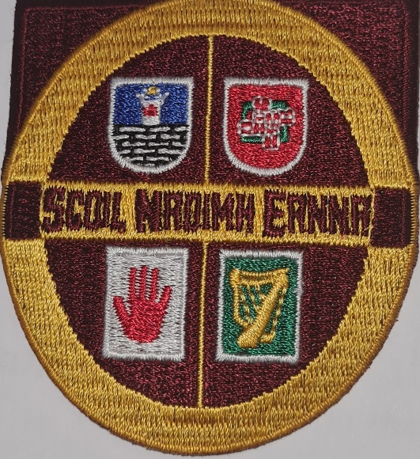
Scoil Naoimh Éanna

Killanny

Code of Discipline

Aims:
Our code aims to create a caring, ordered environment based on respect and tolerance where each child can feel secure and confident. Every effort will be made by all members of staff to adopt a positive approach to behaviour in the school.

Strategies to promote Positive Behaviour:
Ensuring that pupils are treated fairly, equally and firmly
- A quiet word or gesture to show approval
- Matching work with pupil’s abilities. A prize/reward scheme carefully noted by the teacher to ensure that all children at regular stages during the school year are rewarded for effort/behaviour/skill etc.
- A comment in a pupil’s exercise book
- A visit to another member of staff or the Principal for commendation
- A word of praise in front of a group or class.
- Delegating some responsibility or privilege.
- A mention to a parent – written or verbal.
- Teacher records improvement in the behaviour of a disruptive pupil.
The above list is not comprehensive and consists of examples only. Each class has their own age-appropriate strategies to promote good behavior,

The rules outlined in this policy provide clear guidelines for members of our school community and senior pupils as to what type of behaviour is expected of pupils and adults within our school.. These rules let the children know what is expected of them, in a language they understand and incorporate our school motto.

Our Motto: Show Respect and Expect Respect.

Children from Junior Infants – 6th classes will be reminded of these rules and discuss them regularly.

Be Gentle Don’t hurt anyone
Be kind and helpful Don’t hurt people’s feelings
Be honest Don’t cover up the truth
Work hard Don’t waste time
Look after property Don’t damage anything
Listen to people Don’t interrupt.

Behaviour in Class and in School Building:
- Pupils must not behave in such a manner as to disrupt class work or to cause unnecessary disturbance.
- It is school policy that every pupil listens to the class teacher, works hard; making best use of their time in school and does their best.

Behaviour in the Playground:

Yard behavior is to be guided by RESPECT and anything that deviates from that is regarded as misbehavior.
- All pupils have a right to enjoy their time out in the playground in a safe environment at break periods.
- Misbehaviour consists of any action that puts the safety of self or others at risk.
- Fighting, rough play or any physical force is never allowed or tolerated.
- In the interests of safety, climbing on the school walls/fences is strictly forbidden.
- There will be a time-out zone clearly marked out at the front of the school . Children will have to stay in this zone for a set time as punishment for minor misbehaviours. Firstly they will be given a verbal warning then if offence is repeated , they must go into zone for a set time. Date of offences will be recorded in the class list in yard folder. If a child receives three time- outs, then they must do ten minutes detention at lunchtime. This will be supervised by the class teacher and will consist of copying lines outside the staff-room. These lines will be prepared by each teacher and a supply kept in the office. SEN pupils will be exempt from these sanctions but will be reprimanded verbally. At the end of each month the slate will be wiped clean.
- Common incidents will not be communicated to class teacher after lunch but if unresolved then children will go to teacher concerned at lunchtime the next day.
- If children incur a serious injury on yard then their parents will be notified by the secretary through a text on Aladdin.
- When the bell rings during playtimes the children stop playing and freeze ,then they proceed to walk to their class lines when the whistle is blown by the teacher on the yard . Children do not enter the school building without getting permission from teachers.

School Rules

School rules are devised with regard to the health, safety and welfare of all members of the school community. It is imperative that adults ‘practise what they preach’ in their interaction with children every day. The School Rules listed below provide clear guidelines for all members of the school community.

- Pupils enter and leave the school building at all times in an orderly fashion.
- In the interest of safety pupils must walk within the school building and leave and enter classrooms quietly.
- Pupils are expected to treat all staff members, themselves and each other with due respect and courtesy. Pupils are taught to stand back for an adult, to welcome visitors and to show respect for their elders.
- Bullying is never allowed. Any behaviour that interferes with the rights of others to learn and to be safe is unacceptable.
- Bad language is unacceptable. Inappropriate language if used towards a teacher or anywhere within the school is considered a serious breach of the code.
- We encourage pupils to wear their full school uniform
- Chewing gum, glass bottles, correction fluids, other solvents, matches, cigarettes, alcohol or drugs are not allowed.
- Jewellery is not allowed except for one small stud earring in the bottom of each ear and a watch. If jewellery is deemed to be a danger to themselves or others children will be requested to remove it.
- Make-up is not worn during school times
- Cycling in school grounds is forbidden
- We encourage children to bring healthy lunches to school. (see Healthy Lunch Policy)
- Children are not allowed Mobile phones in class or on the school yard. If a child is found with a mobile phone it will be confiscated and kept in the office until a fine is paid.
- We encourage hairstyles to be kept neat and conventional – with hair in its natural colour. For hygiene purposes long hair must be tied back.
- Pupils must respect the school building and property. If any deliberate damage is caused, the parent/guardian will be responsible for the cost of repair/replacement.

Procedures:

The degree of misbehaviour i.e. minor, serious or gross, will be judged by the teachers and/or Principal based on a common sense approach with regard to the gravity/frequency of such misbehaviour as follows;

1. Examples of minor misbehaviour:
Interrupting class work/arriving late for school/running in the school building/leaving litter around the school/not wearing the correct school uniform/being discourteous/unmannerly /not completing homework without good reason/not having homework signed by a parent/ endangering self /fellow pupils in the school yard at break time.

Examples of steps to be taken by teachers when dealing with minor misbehaviour:

- Verbal reprimand/reasoning with the pupil
- Noting instance of yard misbehaviour in Yard Book

Examples of steps to be taken when dealing with regular occurrences of minor misbehaviour:

Phase 1 (within the classroom and class):

- Write story of what happened Or one copy of school rules Or relevant rule to upper limit of 20 times ,—all to be signed by parent
- Note in homework journal to be signed by parent/temporary separation from peers as in time –out from an activity.
- Sending to another teacher/denial of participation in some class activity.
- Detention at teachers discretion.

Phase 2:

- Send to the Deputy Principal.
- Send to the Principal.
- Class teacher meets one/both parents.
- Principal/Deputy Principal meets with one/both parents concerning behavior.

2. Examples of serious misbehaviour:
Constantly disruptive in class /telling lies / stealing/ damaging other pupil’s property back answering a teacher / frequenting school premises.

Examples of steps to be taken when dealing with serious misbehaviour;

- Teacher accompanies pupil to the Deputy Principal.
- Send to the Principal.
- Teacher sends note in Journal to be signed by parent.
- Principal meets with one/both parents
- Chairperson of Board of Management is informed and parents requested to meet with the Chairperson and Principal.
- It should be noted that these lists consist of examples only, it is not meant to be a totally comprehensive list of misbehaviours and procedural steps . The procedures will be used judiciously and not necessarily in this order.

Where there are repeated instances of serious misbehaviour, the Chairperson of the B.O.M. will be informed and using the Teacher’s Incident Report Form, teachers will keep a written record of instances of serious misbehaviour as well as a record of improvements in the behaviour of disruptive pupils. Before resorting to serious sanctions e.g. suspension, the normal channels of communication between school and parents will be utilised. Parents will be involved at an early stage, rather than as a last resort. Communication with parents will be verbal or by letter, depending on circumstances. The parents concerned will be invited to come to the school to discuss their child’s case.
Parents will be requested in writing to attend at the school to meet the Chairperson, the Principal and Class Teacher. If parents do not give an undertaking that the pupil will behave in an acceptable manner in the future, the pupil may have to be suspended for a temporary period. Suspension will be in accordance with the terms of the Rules for National Schools.
All members of the teaching staff, B.O.M. and Parents Representatives are involved in planning this code.

In the belief that the most effective schools tend to be those with the best relationships
with parents, every effort will be made by the Principal and staff to ensure that parents are kept well informed, that the school provides a welcoming atmosphere towards parents, and that parents are not only told when their children are in trouble but when they have behaved particularly well.

At all times teachers will strive to catch the children engaging in positive and expected behaviours.

This code will be reviewed at agreed intervals.

This Code was reviewed and ratified by the BoM on 6th April 2022

